Exhibition at the Metropolitan Museum of Art,
October 10, 2022 - January 8, 2023
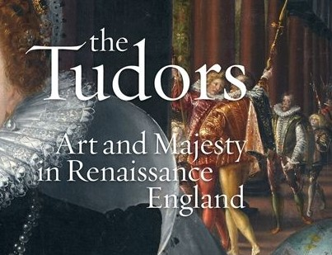

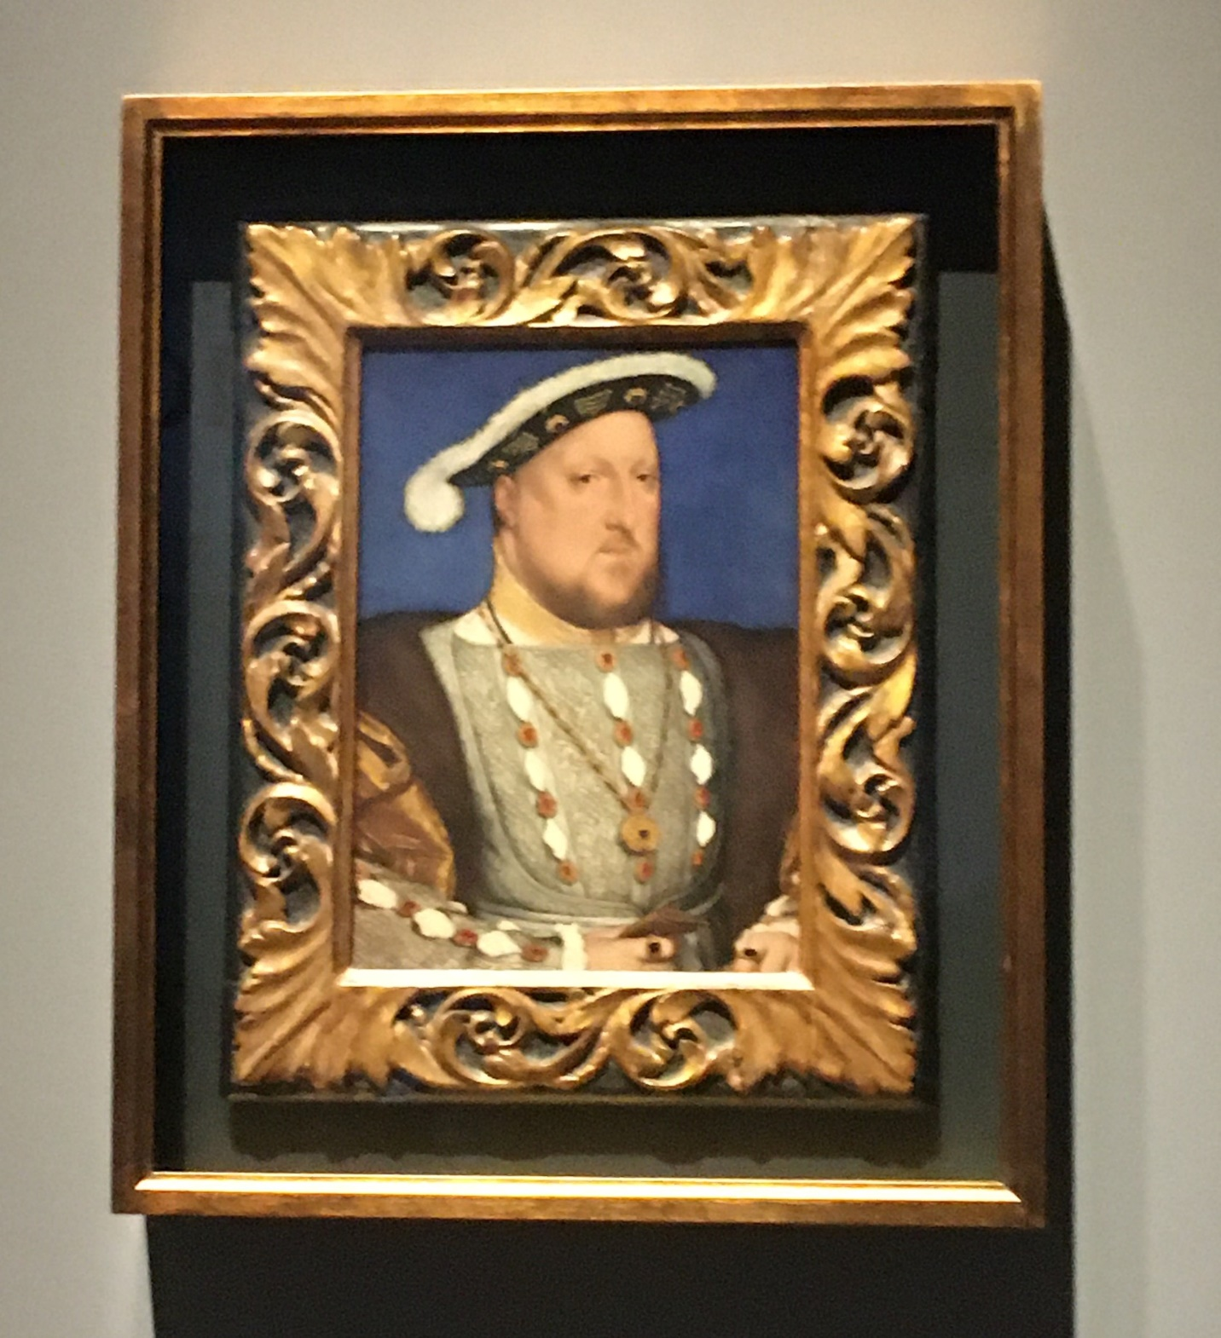
King Henry VIII was a noted sportsman in his day. An avid falconer, his life was saved (to the regret of future wives) when his professional falconer pulled him out of the muck in which he was stuck fast. A true falconer will risk his life for his prized falcon, the kingdom be damned. Oil on panel by Hans Holbein the Younger (1497/8 - 1543). From the collection of Museo Nacional Thyssen-Bornemis, Madrid, Spain.

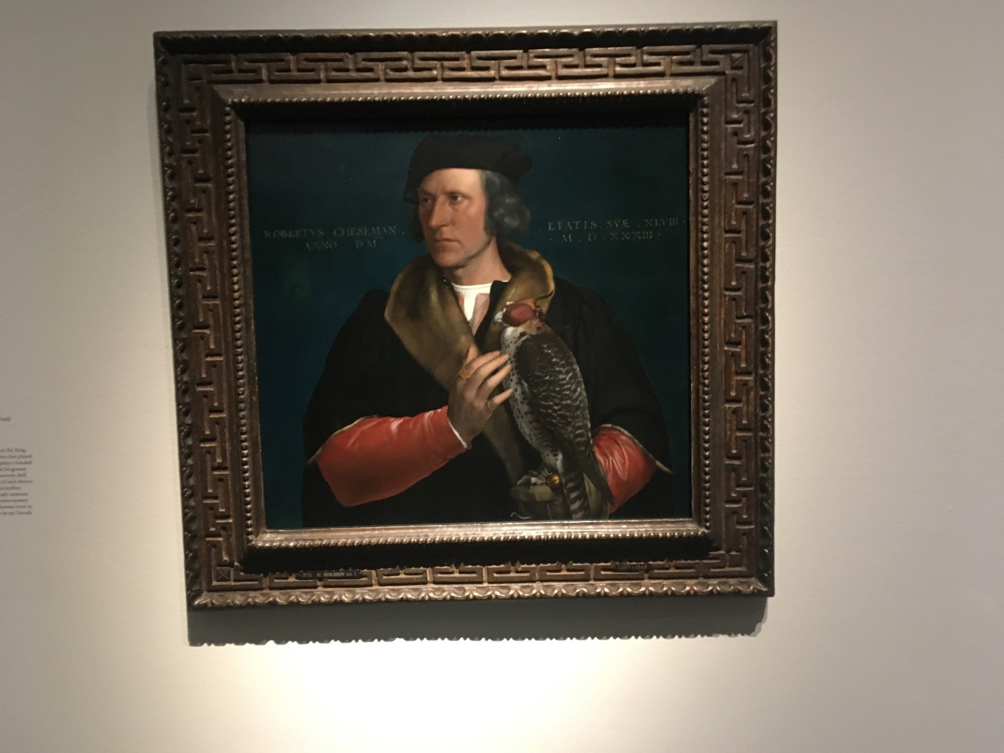
Robert Cheseman (1543) by Hans Holbein the Younger (149/8-1543). Cheseman served as falconer to King Henry VIII, accompanying the king on his hawking expeditions which played a central role in courtly life. Chesemen is shown with a hooded gyrfalcon. From the Maurithaus, The Hague, Netherlands.

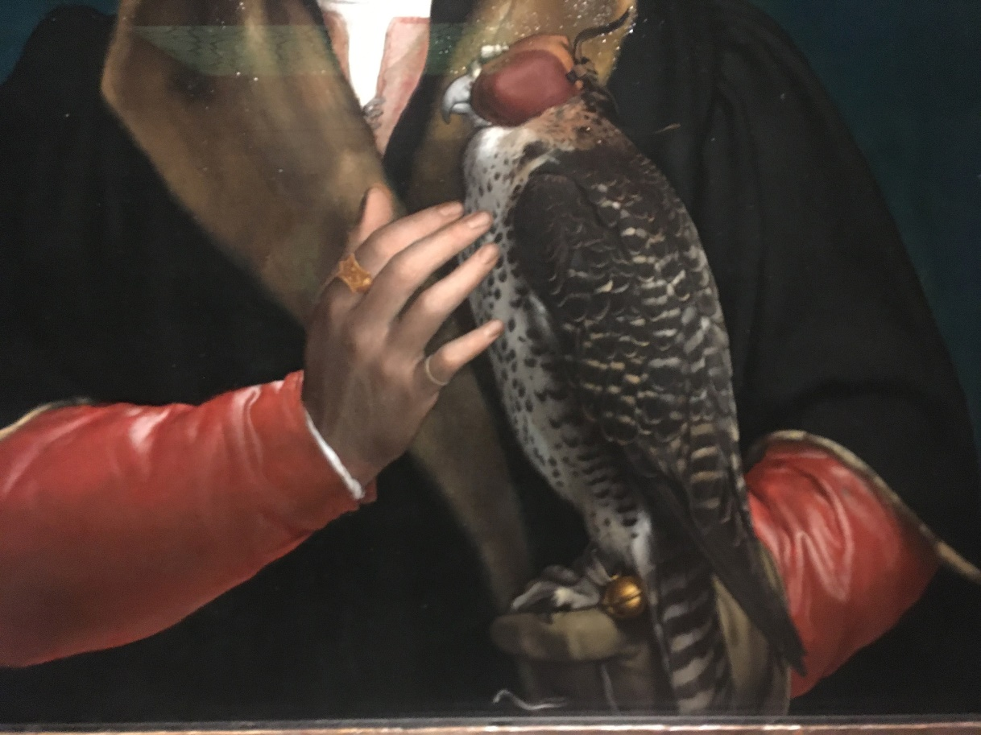
Robert Cheseman's falcon.

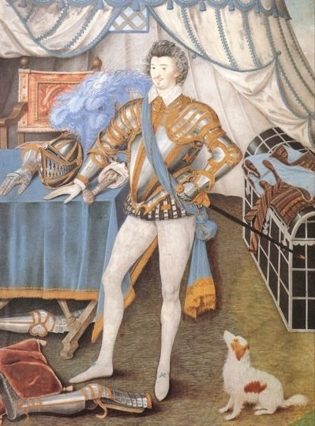
Sir Anthony Mildmay, Knight of Apethorpe, Northamptonshire, painted circa 1590-1593. The artist is Nicholas Hilliard (c.1547-1619). Sir Anthony was a falconer. The Archives of Falconry in Boise, Idaho has one of his silver varvels, Accession # 2007.131.3. From the Cleveland Museum of Art.
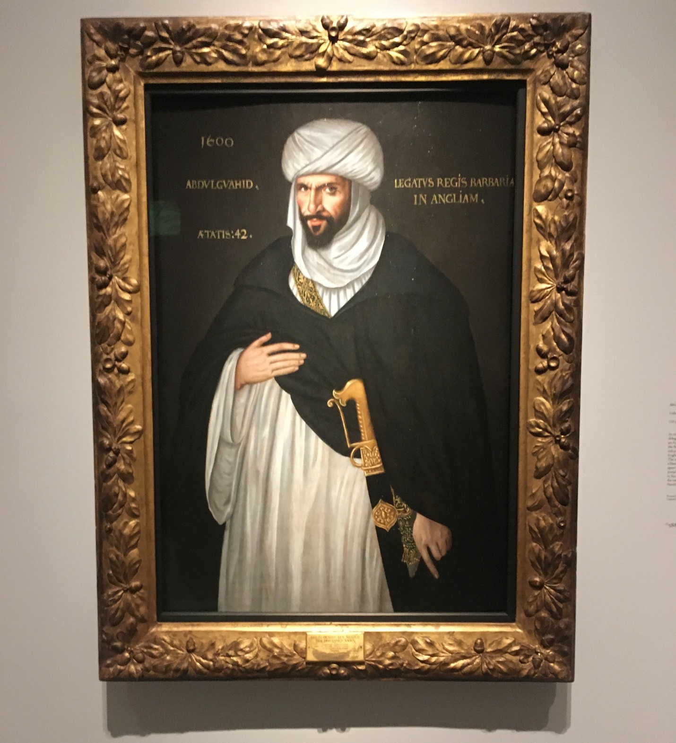
Abd el-Ouahed ben Messaoud ben Mohammed Anoun, Moorish Ambassador to Queen Elizabeth I. In 1600 Ahmad al-Mansur, Sultan of Morocco, sent this man as ambassador to the Tudor court. Though London was a cosmopolitan city with foreigners such as he present, he cut so striking a figure that his portrait was painted by an unknown British artist. Of course he was a falconer! From the collection of Birmingham University.

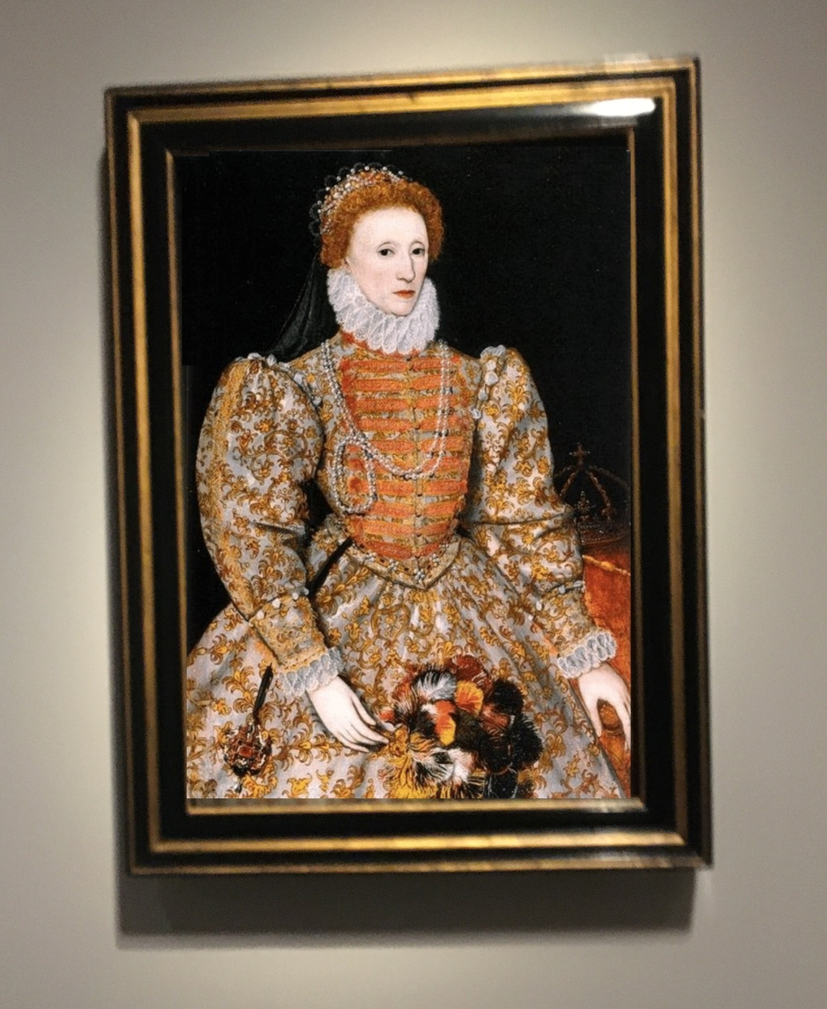
Queen Elizabeth I, (1533 - 1603) This is known as The Darnley Portrait and was painted in 1575 by an unknown Netherlandish artist. Elizabeth was an avid huntress with hawks and hounds, famous for her breeding of "pocket beagles" which could be carried into the field in saddlebags on horses. From the National Portrait Gallery, London.

Compiled by Peter Barry Devers on 19.12.2022 for FB group “Falconry Art”.

