**The old falconer in Xinjiang**

China.org.cn, November 29, 2014

**Editor's note**: Qiali Puhan, a 71-year-old native of Sal Jock Town in Barkol Kazakh Autonomous County in Xinjiang, lives with falcons. Falconry has been a lifelong hobby of his, one which he first took up to help his family survive in hard times. The carnivorous falcon would bring back its prey -- rabbits, pheasants and foxes -- for the starving people to eat. But now Qiali Puhan merely keeps falcons for fun.

|  |
| --- |
|  |

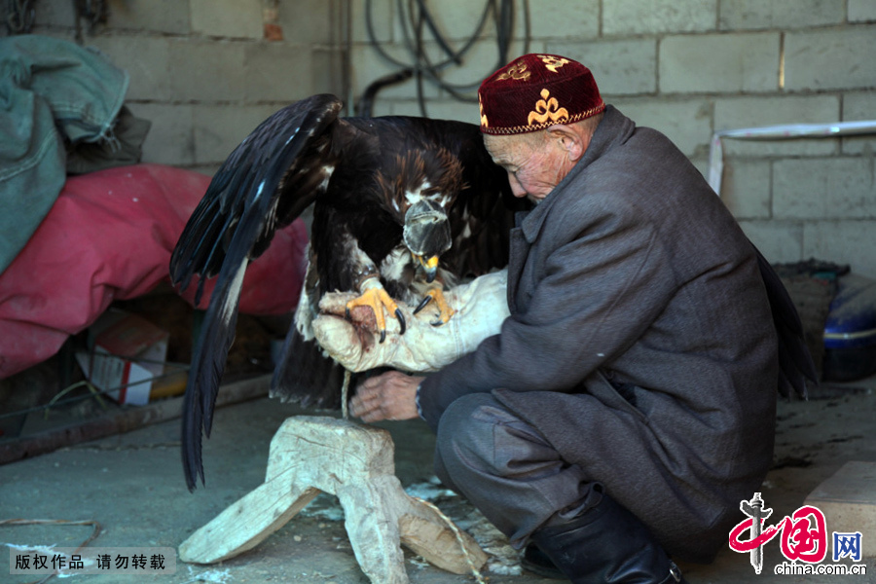

Qiali Puhan prepares to take a short walk on Nov. 23, 2014. [Photo by Sun Jihu/China.org.cn]

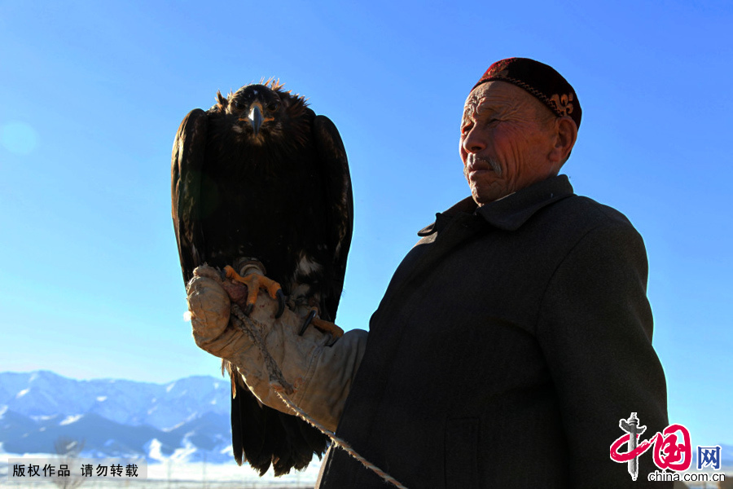

Qiali Puhan roams around his corn field, which extends to the snow-capped Tianshan Mountain, with his falcon resting on his arm. In the past years, the man used to go hunting with the falcons he tamed to feed his starving family with their prey. [Photo by Sun Jihu/China.org.cn]

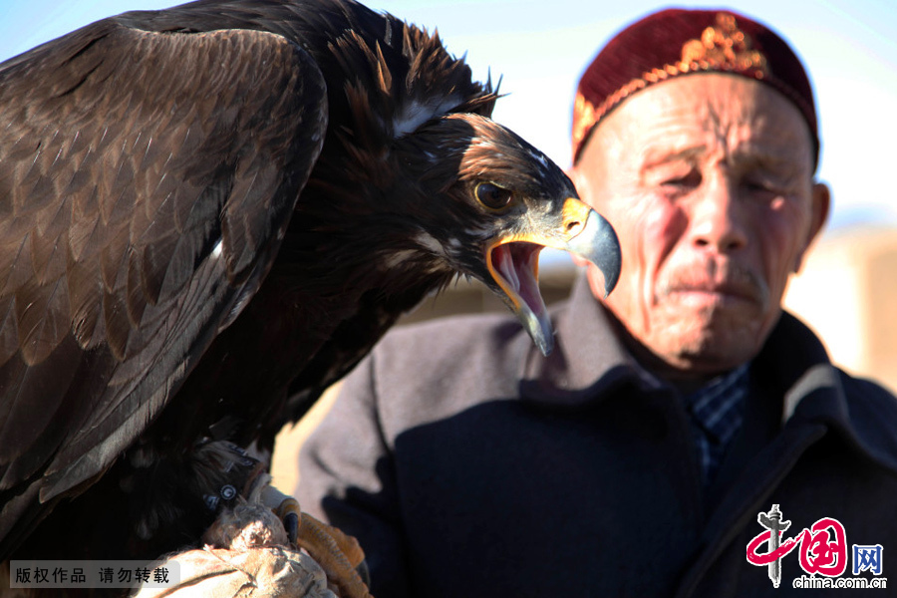

The weight of a one-year-old 10-kilogram falcon is too much for Qiali Puhan, a 71- year-old man, to support with a single arm. Despite the chilly weather, the falcon screeches against the clear blue sky. [Photo by Sun Jihu/China.org.cn]

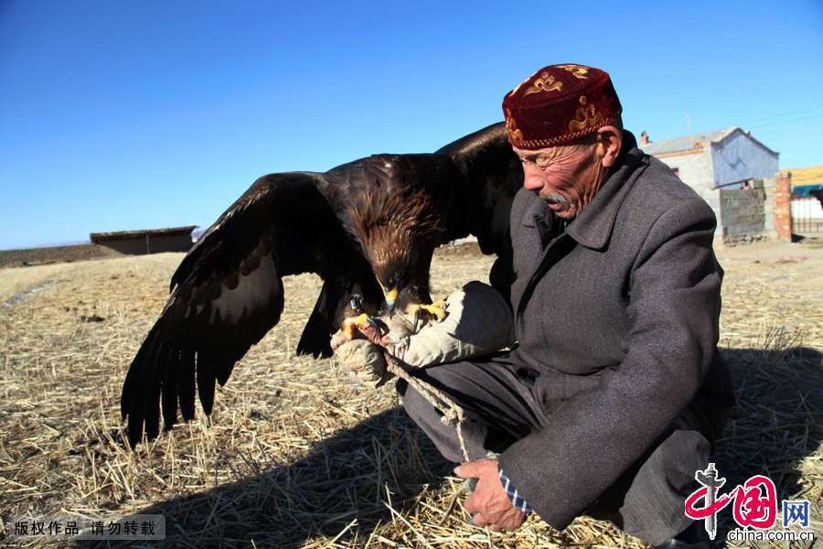

Qiali Puhan feeds the falcon with two pieces of mutton, which might seem too meager for the ferocious appetite of the hawk. [Photo by Sun Jihu/China.org.cn]

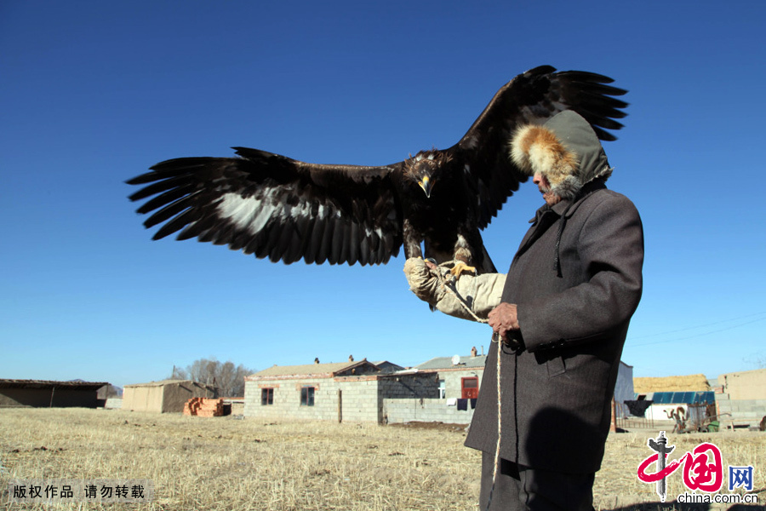

Under Qiali Puhan, the little falcon's wingspan has grown to more than one meter. An adult falcon, which is almost as big as a calf, has a huge appetite for meat, which is too costly for an old man like Qiali Puhan. Therefore, the old man only raises juvenile falcons and then releases them when they are fully grown. [Photo by Sun Jihu/China.org.cn]

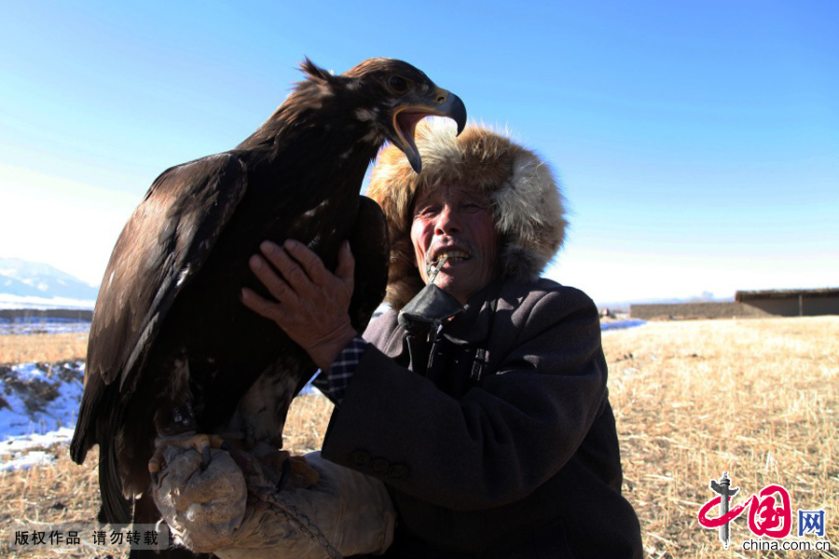

Qiali Puhan, known for his falconry in his hometown, smooths the falcon feathers. His falconry skill has won him numerous awards, including one from the local public security bureau. [Photo by Sun Jihu/China.org.cn]

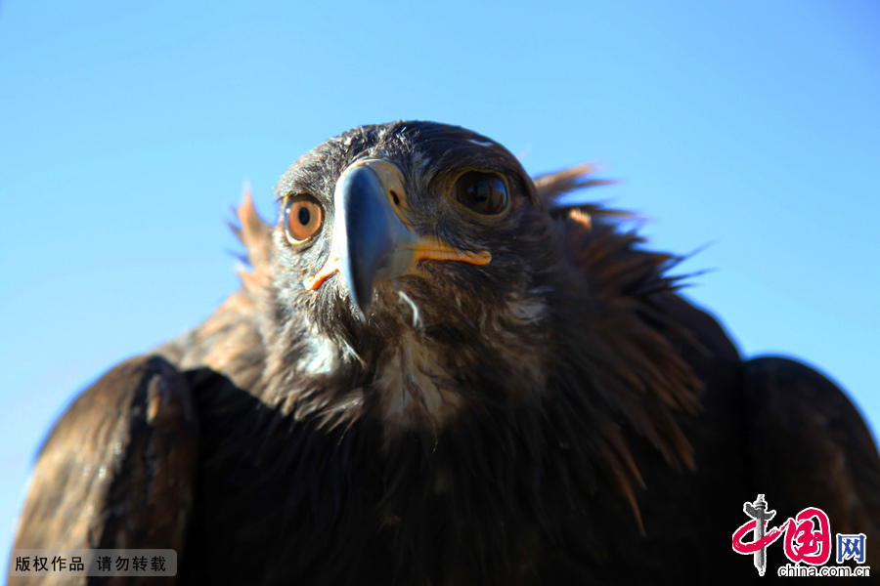

Because the government has banned hunting in the grassland for ecological concerns and because his family is no longer suffering from starvation, the old man has stopped hunting with falcons. But Qiali Puhan is so attached to his lifelong hobby that he cannot help but keep raising young falcons and taking them out on his arm. [Photo by Sun Jihu/China.org.cn]